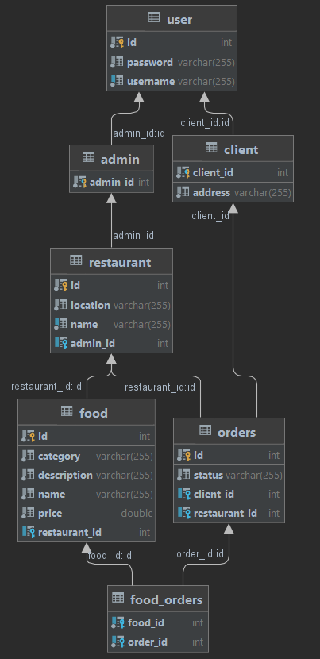create table user  
(  
 id int auto_increment  
 primary key,  
 password varchar(255) not null,  
 username varchar(255) not null,  
 constraint UK_sb8bbouer5wak8vyiiy4pf2bx  
 unique (username)  
);  
  
create table admin  
(  
 admin_id int not null  
 primary key,  
 constraint FK1yevfomeqligdjkhp9g3e2d7r  
 foreign key (admin_id) references user (id)  
);  
  
create table client  
(  
 address varchar(255) not null,  
 client_id int not null  
 primary key,  
 constraint FKhk6hb1d4x2doa9kwctlsx7qvg  
 foreign key (client_id) references user (id)  
);  
  
create table restaurant  
(  
 id int auto_increment  
 primary key,  
 location varchar(255) not null,  
 name varchar(255) not null,  
 admin_id int null,  
 constraint UK_i6u3x7opncroyhd755ejknses  
 unique (name),  
 constraint FKn1h9k9ftcn9y8wsf6ctwbag8p  
 foreign key (admin_id) references admin (admin_id)  
);  
  
create table food  
(  
 id int auto_increment  
 primary key,  
 category varchar(255) not null,  
 description varchar(255) not null,  
 name varchar(255) not null,  
 price double not null,  
 restaurant_id int null,  
 constraint FKm9xrxt95wwp1r2s7andom1l1c  
 foreign key (restaurant_id) references restaurant (id)  
);  
  
create table orders  
(  
 id int auto_increment  
 primary key,  
 status varchar(255) not null,  
 client_id int null,  
 restaurant_id int null,  
 constraint FK17yo6gry2nuwg2erwhbaxqbs9  
 foreign key (client_id) references client (client_id),  
 constraint FKi7hgjxhw21nei3xgpe4nnpenh  
 foreign key (restaurant_id) references restaurant (id)  
);  
  
create table food_orders  
(  
 food_id int not null,  
 order_id int not null,  
 constraint FK7gg88jnhapq39ffsxmqn93l5x  
 foreign key (food_id) references food (id),  
 constraint FKexcbhl9grd0618b45shxyq03s  
 foreign key (order_id) references orders (id)  
);

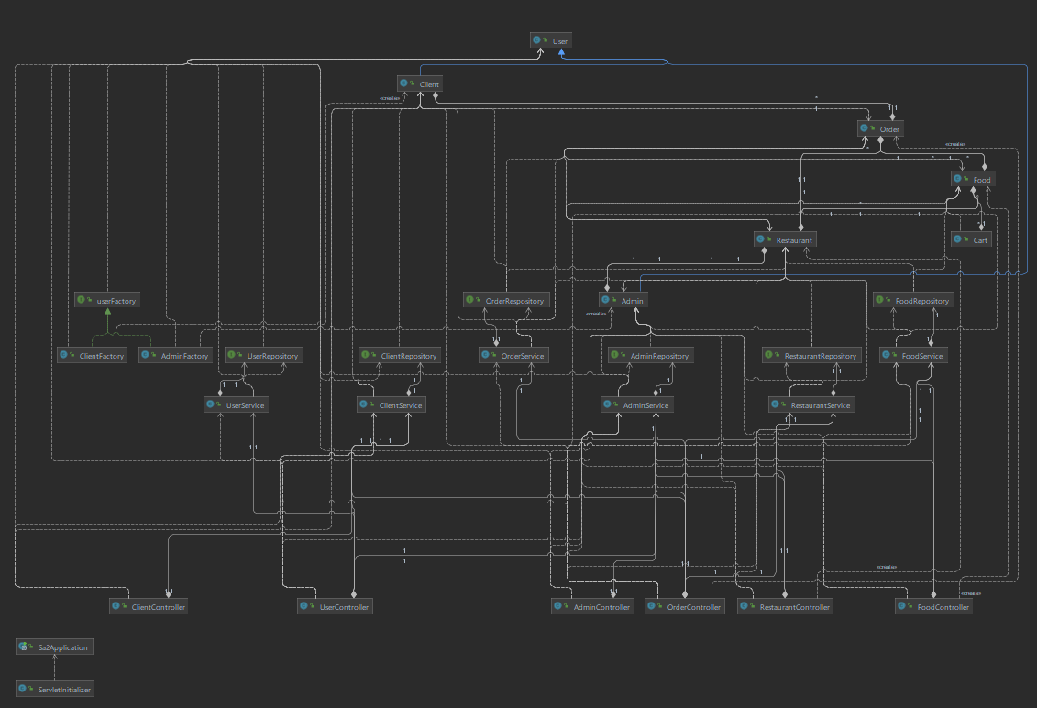



See Order History

Modify Order Status

Create Restaurant and Menu

Create Order

Log In/ Sign Up

Client

Admin